|  |
| --- |
| SYI Games |
| 2D SSAC Shot! |
| **2D Shooting Game Maniacs** |
| Version #0.4.2  All work Copyright © 2015 by SYI Games.  All rights reserved. |
| **[Sangbeom Yi; 300857600]** |
|  |

**Logo.png**

|  |
| --- |
| October 5, 2015 |

**Table of Contents**

[Your Table of Contents should go here. Make sure that your document’s sections are hyperlinked to their corresponding pages.]

**# GitHub (it’s more newest than eCentennial Dropbox)**  
https://github.com/SeanSBYi/2D_SSCA_SPACE_SHOOT/

**#eCentennial Dropbox**

**Version History**

--------------------------------------------------------------------------------

All Source code has each version History

|  |  |
| --- | --- |
| Cap 2015-10-05 14-02-22-098.png | |
| Cap 2015-10-05 14-02-39-124.png | Cap 2015-10-05 14-02-57-501.png |

--------------------------------------------------------------------------------

Version 0.1.0  
Create default Camera, Player, Enemy  
Scroll Background

Version 0.2.0  
 Player can shot the bullet

Version 0.2.1  
Make Enemy shot function

Version 0.2.5  
Make enemy crowd pattern

Version 0.3.1  
Check a collision [Player to Enemy, Bullet to Enemy]  
Score board

Version 0.3.3  
Game Over and High Score

Version 0.4.1  
Make a Boss Enemy

Version 0.4.2  
Add Player HP

-----------------------------------------------------------------------------------------

1. **Game Overview**

*Get ready to descend into Bullet Hell! You must survive on the battlefield and get the high score!*

1. **Game Play Mechanics**

*Shot and Destroy the enemy.*

1. **Camera**

*Top view width-scroll 2D space shooting game. Fixed.*

1. **Controls**

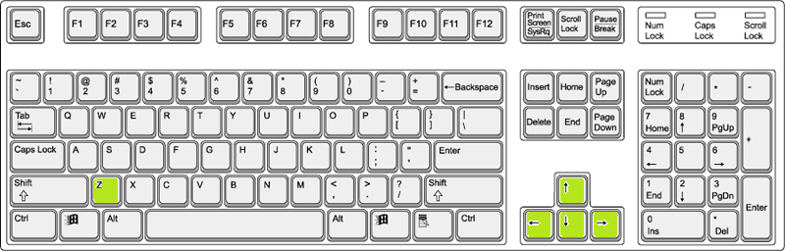

* *Up, Down, Left, Right : My Character (ship) move*
* *Z : Start Game (Title Menu)*

*Shot a bullet (Playing Game)*

1. **Saving and Loading**

*This game doesn’t support the save and load*

*But it can remember your “High score”*

*(*If turn off the game, your high score will be deleted)*

1. **Interface Sketch**

Current Score

*Enemy*

*Hit*

*Player*

High Score

1. **Menu and Screen Descriptions**

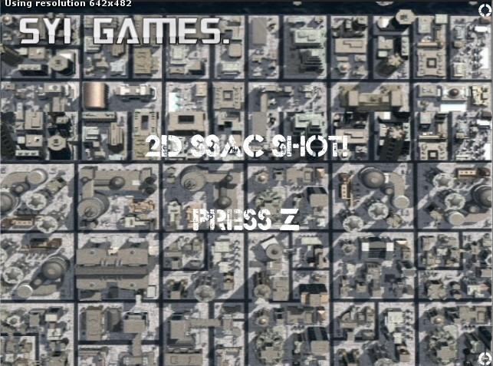

*[Title Screen]*

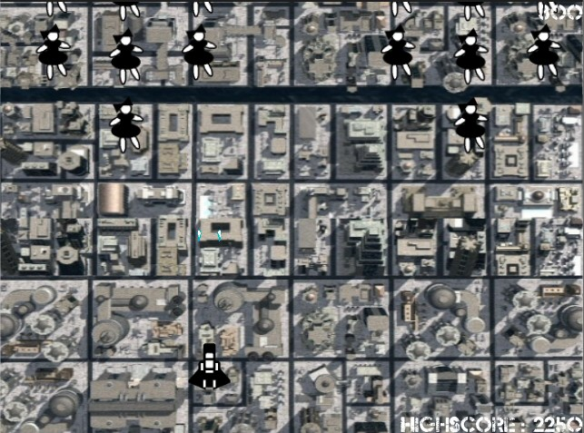

*[Main Game Screen]*

1. **Game Progression, Levels**

*1-4 waves spawn normal enemy.*

*5 wave spawn Boss enemy.*

*After 5 wave, repeat 1 wave.*

1. **Enemies, Non-player Characters**

*Some of Enemy pattern was written manually.*

*Empty Object only has transform (position). 3-5 Object made groups and Spawn use their position.*

**

*[Boss Enemy] [Normal Enemy]*

1. **Weapons**

*1. Normal shot*

*2. Homing shot (Version 0.5.1 Expected)*

1. **Items (Version 0.6.1 Expected)**
2. *Shield*
3. *HP Recover*
4. **Scoring**

*Normal enemy : 100 point*

*Boos : 1000 point*

1. **Sound Index**

*Effect: Explosion Effect Sound, Player shot Bullet Sound.*

*BGM : FunkyTonk*

#Open Source :  
http://www.econovation.co.kr/ecnvb/%EA%B0%9C%EB%B0%9C%EC%9E%90-%EC%A7%80%EC%9B%90/%EC%98%A4%ED%94%88%EC%86%8C%EC%8A%A4/

1. **Design Notes**

*(Include additional design notes here)*

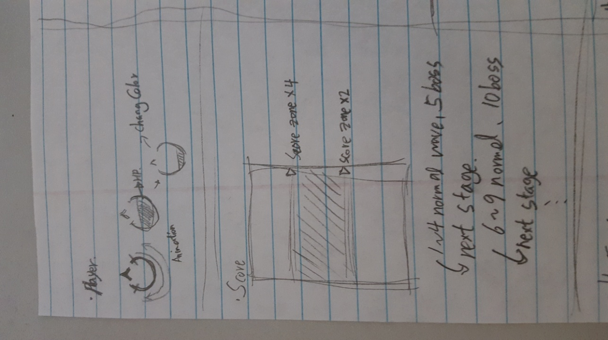

*[Player Design, Stage Score Table and wave Design]*

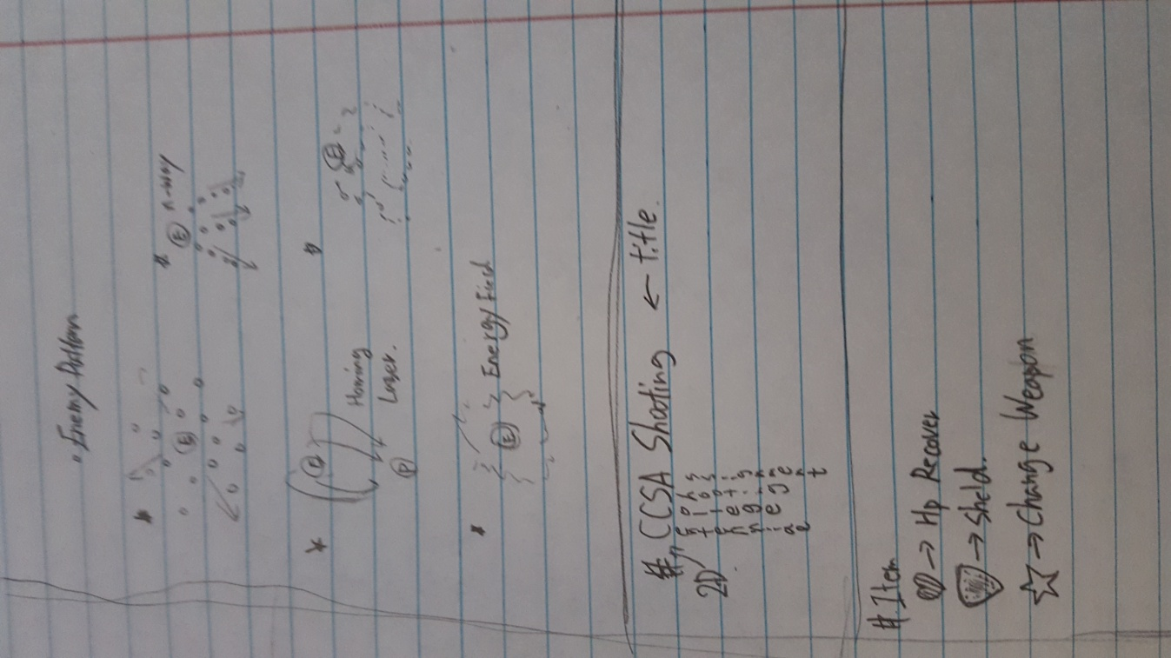

*[Enemy pattern, Title name, Item Design]*

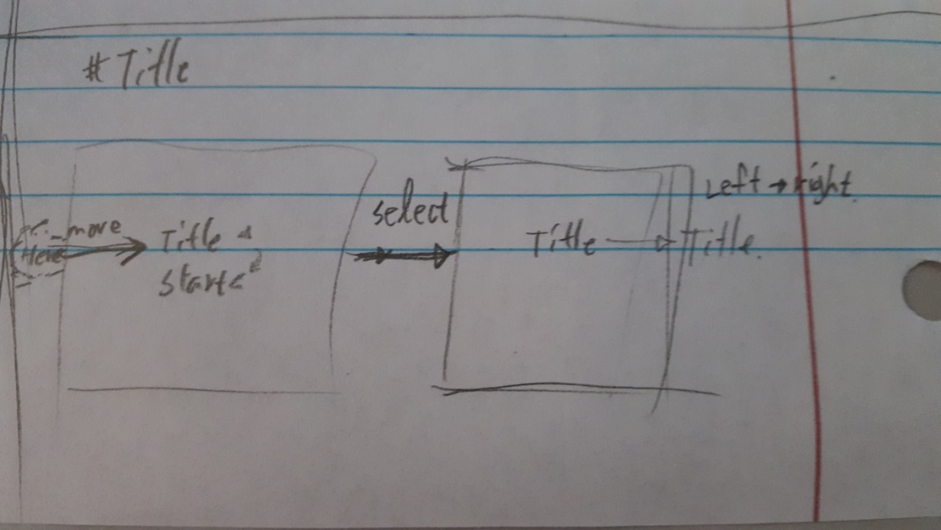

*[Title Menu Design: Future Features]*

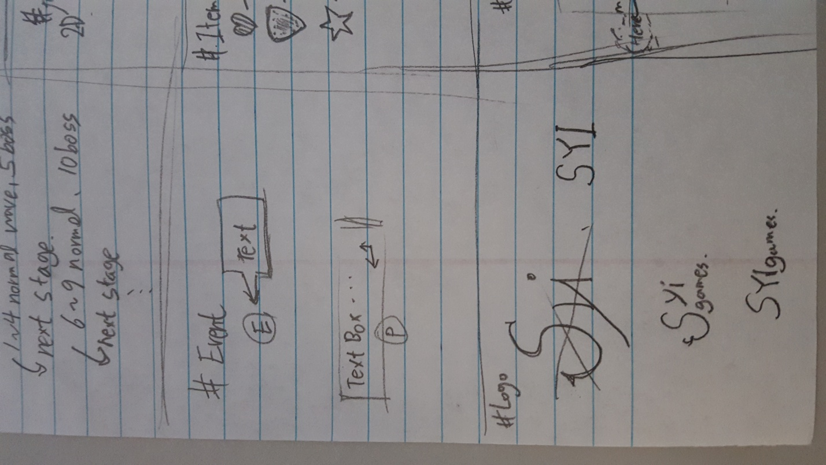

*[Logo Design, Event Design; Future Feature]*

1. **Future Features**

*Playable Character*

*2-4 Type Ship (Player Character)*

*Design Change*

*Various Type of Enemy*

*New Design and Animation*

*Various Type of Shooting*

*Bullet Type*

*New score combo System*

*Check the distance player to enemy, if two objects are close, player can get higher score.*

*New Stage  
 1-5 wave -> 1stage  
 Total : 5 stage*

*New Platform  
 Unity Web Player, Mobile*